Step1: Create VWAN

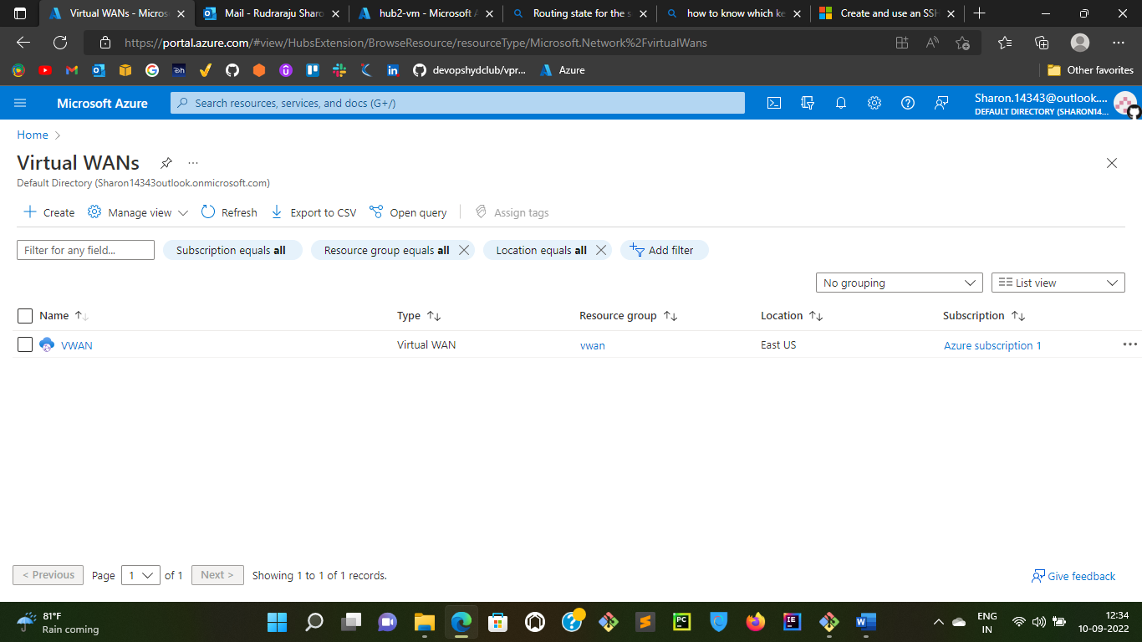

Step2: Create Hub1 and Hub2

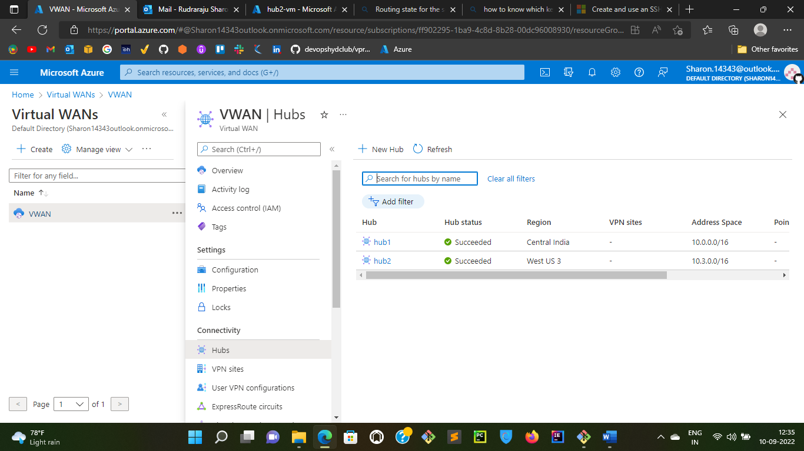

Step3: Create hub1-vnet and hub2-vnet

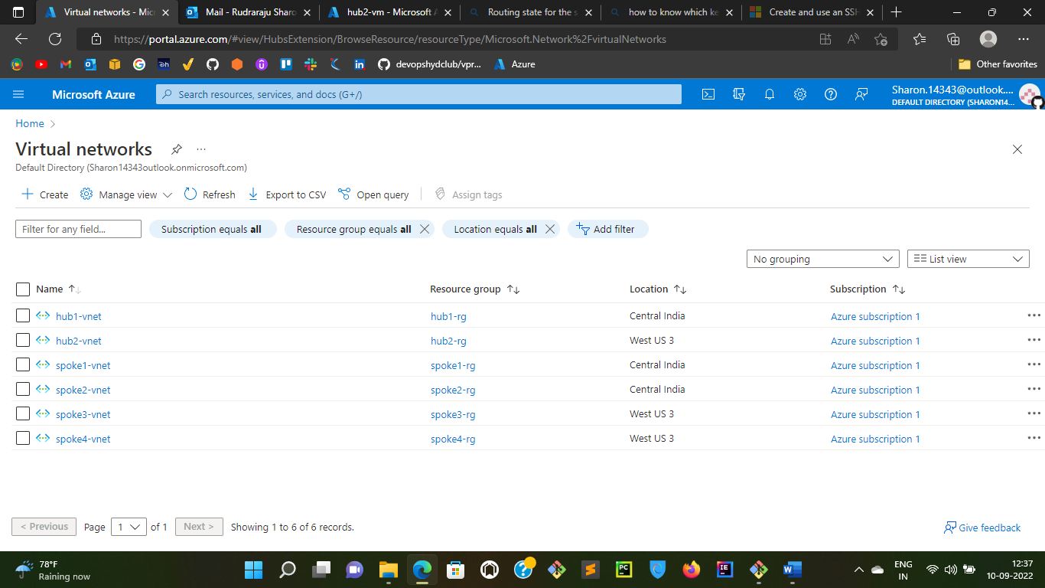

Step4: Create Virtual network connections for both hub1,hub2 and hub1-vnet,hub2-vnet respectively

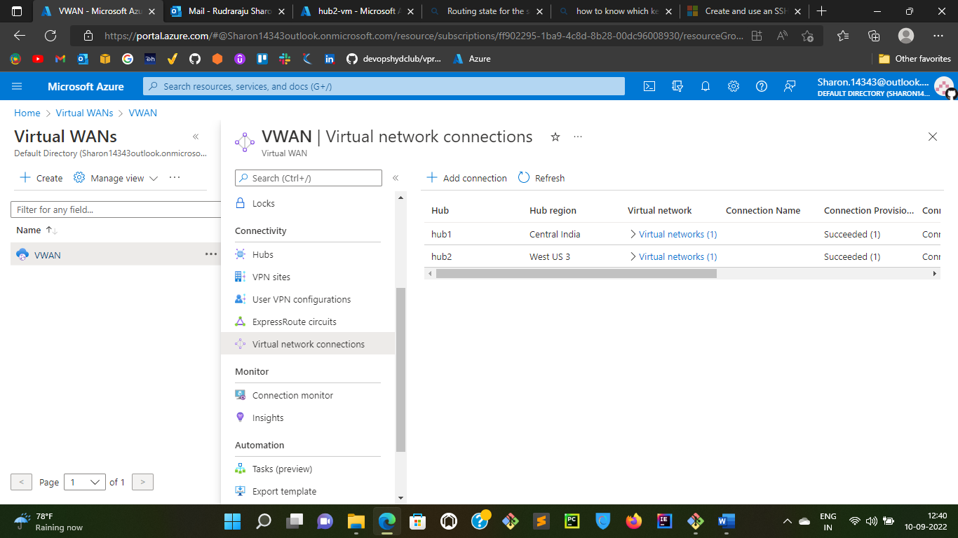

Step5: Create virtual machines in the respective vnet’s and subnets to test the connectivity

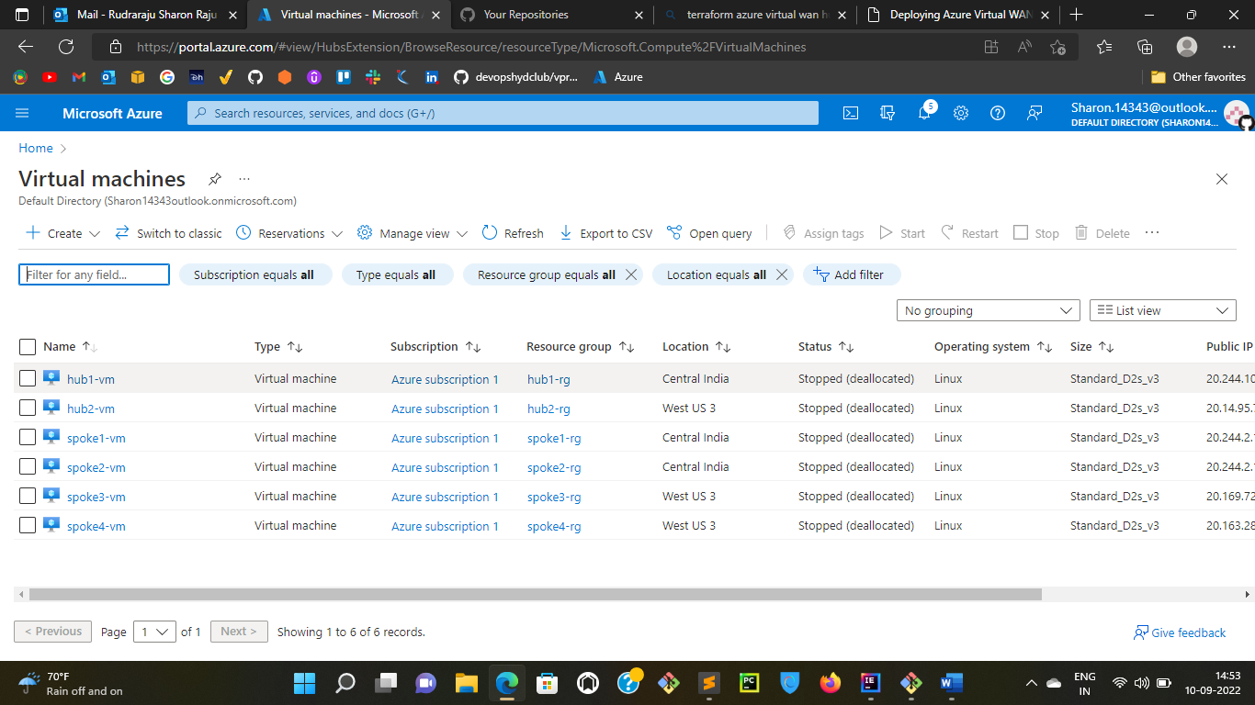

Step6: Login into hub1-vm via ssh and use ping command along with the Private IP of hub2-vm. If the connectivity is successful, you will see the packets is been received.

